Project Design Phase-II
Technology Stack (Architecture & Stack)

Date | 18th June 2026
Team ID
Project Name | Health Connect
Maximum Marks | 4 Marks

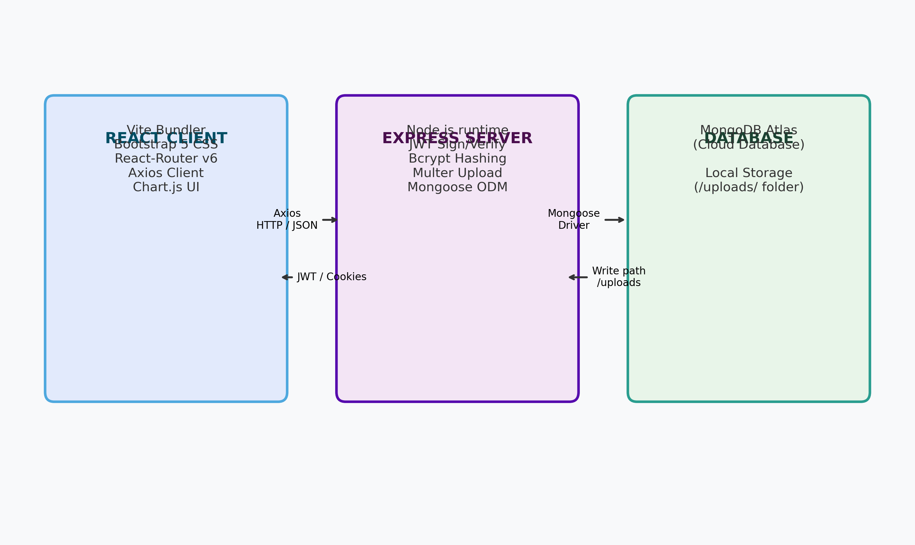
The Deliverable shall include the architectural diagram as below and the information as per the table1 & table 2
Example: Order processing during pandemics for offline mode
Guidelines:
Include all the processes (As an application logic / Technology Block)
Provide infrastructural demarcation (Local / Cloud)
Indicate external interfaces (third party API’s etc.)
Indicate Data Storage components / services
Indicate interface to machine learning models (if applicable)


Table-1 : Components & Technologies:
S.No | Component | Description | Technology
1 | User Interface | Web dashboard for patients, doctors, and admins. | HTML, CSS, JavaScript, React.js, Bootstrap 5
2 | Frontend Router | Client-side page navigation router. | React Router DOM v6
3 | Application API Server | Server logic for auth, prescriptions, bookings, locker. | Express.js, Node.js
4 | Encryption & Auth | Password hashing and session token verification. | Bcrypt.js, JSON Web Tokens (JWT)
5 | File Upload Middleware | Multer middleware handling file uploads. | Multer
6 | Database | Document-based flexible data storage. | MongoDB, Mongoose ODM
7 | Local File Storage | Directory storing medical reports (PDF/JPG/PNG). | Local filesystem (uploads/)
8 | Analytics Charts | Dynamic charts representing clinic metrics. | Chart.js, react-chartjs-2
9 | Infrastructure / Server | Development environment deployment config. | Render.yaml service configs, local host

Table-2: Application Characteristics:
S.No | Characteristics | Description | Technology
1 | Open-Source Frameworks | Utilizes fully open-source modular components. | React, Express, Node.js, MongoDB
2 | Security Implementations | Secure password storage, role guards, JWT validation. | Bcrypt, JWT validation headers, Multer validation
3 | Scalable Architecture | Decoupled 3-tier presentation, logic, and data layers. | MERN Stack decoupled web service architecture
4 | Availability | Configured environment routing with dotenv. | Dotenv configurations supporting cloud environments
5 | Performance | Mongoose indexing, client state, and component memoization. | React performance optimizations and Mongoose indexing

